Hayden Thorpe
New album Ness out today – listen here
Shares video for “V” – watch here
Confirms new tour dates for 2025
Performing at London’s Brick Lane Books next week

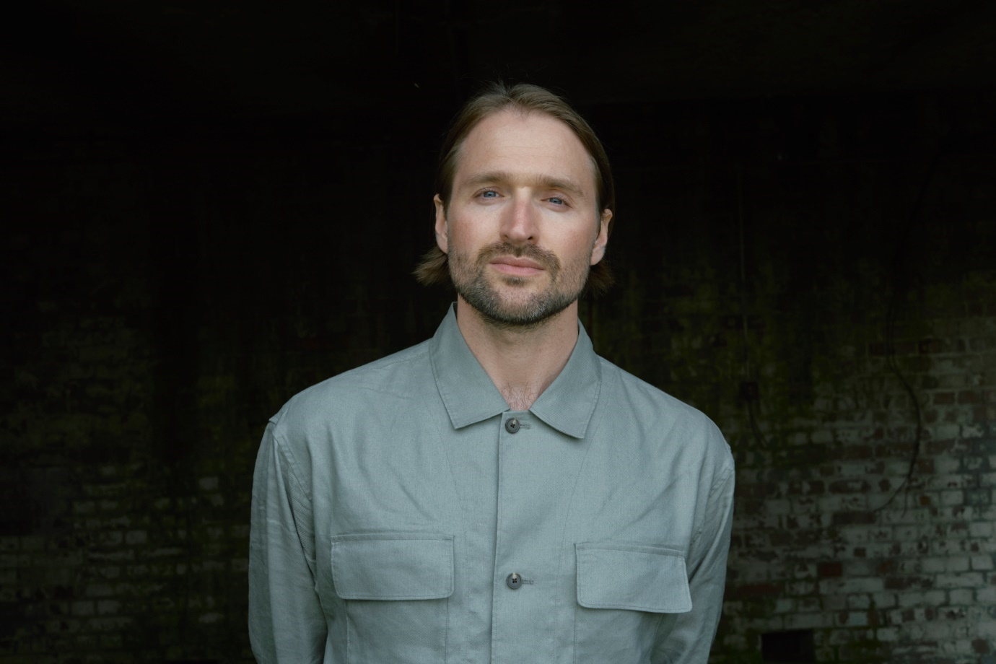
Photo credit: Eeva Rinne

“The 13 tracks of Ness offer calm with a suitably disquieting undertow, rather like the place itself, with Thorpe’s countertenor adding to the melodrama” Mojo 4*
“Poetic, windswept electronic pop” Uncut 8/10
“A remarkable, absorbing, often stunning experience” Clash 9/10
“Thorpe has woven a tapestry of sound that’s as enigmatic as the former weapons testing site that inspired it” Dork

Today, Hayden Thorpe releases his third studio album Ness. Inspired by Orford Ness, a ten-mile long shingle spit on the coast of Suffolk, the former Ministry of Defence site during both World Wars and the Cold War, it was acquired by the National Trust in 1993 and left to re-wild. To this day, it remains a place of paradox, mystery and constant evolution. Using a process of redaction, Thorpe brings the songs to life from the words of pioneering, best-selling place writer Robert Macfarlane’s book of the same name.

Also shared today, is the video for “V” directed by Molly Gromadzki. “V” acts as the climax to the firing song trilogy on the album, talking about the song, Hayden says: “This song is based around the same Moog Subharmonicon synth line that emerged on day one. Kerry Andrew’s vocal arrangement had me in tears when I first heard it. It was the sensation of something beautiful being rendered from a description of horror.”

Watch the video for “V” here.
Stream Ness here.

Whilst the production was a new challenge for Thorpe, he credits his community and collaborators for their support in bringing Ness together. The orchestral parts are played by Propellor Ensemble, whilst Jack McNeill, their band leader arranged all the parts and played clarinet across the record. Kerry Andrew composed and sang all of the choral arrangements and performed some spoken word.

From the sensual, libidinal and free “She” to the uncanny requiem of “Merman”, the contrasts of the Ness landscape are heard in the music, from folk to experimental orchestra to elegant pop. Elements of the Ness found themselves on the record too, such as seeds placed on the bass drum during recording, or thistles rubbed together for the sound of shakers or whirring.

Thorpe feels Macfarlane’s Ness is an important and moving work because “it captures how human and natural action counteract one another, and in this space was the sum total of the human conquest over nature – to split the atom. The ultimate act of defiance is to create your own sun to use for your own means. Ness is a space where we're trying to act as gods, trying to work out how to fling this lightning bolt.” And remarking on the sentiment in our current landscape: “Ness is uniquely qualified to teach us of what has been and what can be. Today, amid new horrors and hostilities, Ness stands as a poignant reminder of those end-of-days-ways and the restorative powers of the natural world.”

Having previously announced a London show for 2025, Thorpe now confirms a full UK + Irish tour. He will be performing at Brick Lane Books next week following the sold-out Ness Speaks weekender at Orford Ness itself.

Upcoming live dates
Saturday 28th September - Ness Speaks: Words and Music, Orford Ness, Suffolk – sold out
Sunday 29th September - Ness Speaks: Words and Music, Orford Ness, Suffolk – sold out
Tuesday 1st October – Brick Lane Books, London – sold out
Saturday 23rd November - Mountain Festival, Kendal
Saturday 25th January – Brewery Arts Centre, Kendal
Sunday 26th January – Celtic Connections @ City Halls Recital Room, Glasgow
Tuesday 28th January – Music Room, Liverpool Philharmonic Hall, Liverpool
Wednesday 29th January – National Centre For Early Music, York
Thursday 30th January – Sage 2, The Glasshouse International Centre For Music, Gateshead
Friday 31st January – The Gate, Cardiff
Saturday 1st February – The Lantern, Bristol Beacon, Bristol
Sunday 2nd February – Blackwell Performance Space, Birmingham Symphony Hall, Birmingham - matinee
Tuesday 4th February – Norwich Arts Centre, Norwich
Wednesday 5th February – Komedia, Brighton
Thursday 6th February – Storey’s Field Centre, Cambridge w/ Robert Macfarlane
Friday 7th February – Kings Place, London w/ Robert Macfarlane
Wednesday 7th May – Cathedral Quarter Arts Festival @ The Deer’s Head, Belfast
Thursday 8th May – The Grand Social, Dublin
Friday 9th May – St Michael’s Church, Manchester
Tickets

Ness is available to buy on exclusive black Biovinyl (with hand-numbered A4 lyric sheet signed by Hayden Thorpe and Robert Macfarlane), standard black Biovinyl, CD (in partially recycled jewel case) and digitally. Buy: Dom Mart | Digital

Hayden Thorpe Online
Website | Facebook | Twitter | Instagram



